Manufacturing Robotic Work Cell
Manufacturing Technology Academy
Hollianne McHugh and Tim Wheatley
Ben Thelander, Rachel Omerza, Josh Graham, Corrie Noah
Level 2 High School Division
Abstract

At the beginning of the school year four seniors from the Manufacturing Technology Academy (MTA) formed a team—the Wind Turbine Team (WTT)—to compete in the Manufacturing Robotic Work Cell competition at the National Robotics Challenge (NRC). The team used the Plan Do Study Act problem solving method to come up with the idea of building a work cell that would construct small wind turbines.
The creation of this project began with simple SolidWorks models of the turbine itself (the product of the work cell) and eventually to models of the cell frame and components within the cell. A prototype of the hopeful product was developed and showed the team that modifications needed to be made. Once the design was reconfigured, the alternative-energy machine was reconstructed to represent what the products of the work cell would look like.
Then, the WTT began assembly of the frame. This presented many problems as parts were missing, materials were difficult to work with, and components were expensive and took time to acquire. Once the team was able to acquire all necessary parts for the frame, it was constructed as a home for future wind turbine construction.
The team needed to determine what components would be best suited to perform the functions in the cell. Therefore, components were added to the SolidWorks model of the work cell. Everything concerning this clean-energy work cell was student designed and student built, even including sensors on the robot that needed to be fixed.
In the end, the Wind Turbine Team from the MTA was able to design and completely construct a work cell to fight the polluting ways of the modern world. The robotic arm within the cell used the stock PVC pieces and Lexan fins to assemble small wind turbines containing a generator. The product gave a measurable energy output and could someday provide homes with a lighter load of “dirty” energy use.
At the NRC, the team presented its project to a panel of judges and was rewarded with a nomination for the Honda Innovation Award (only 15 out of 400 teams were nominated for this!) and received the Gold Award in the Manufacturing Robotic Work Cell competition.

Table of Contents
Introduction ……………………………......... 1

Plan 1: Document the Background…... 2

Plan 2: Define the Problem or Opportunity 5

Plan 3: Document the Current Situation 6

Do 4: Develop an Action Plan 8-16

Do 5: Implement an Action Plan to Create a Prototype 8-16

Do 6: Test the Prototype 8-16

Study 7: Analyze the Test Results 8-16

Act 8: Standardize the Improvement; Re-engineer the Prototype 8-16

Conclusion 17

Appendix A 18

Appendix B 19

Appendix C 21

Introduction

At the beginning of the 2010-2011 school year, a group of four seniors at the Manufacturing Technology Academy (MTA) took on the task of competing in the Manufacturing Robotic Work Cell competition at the National Robotics Challenge (NRC). As a group of driven, environmentally conscious young adults, the team desired to construct a work cell that would provide for the greater common good. With this in mind, the team was able to come up with an idea for the Work Cell over a matter of a few weeks of brainstorming. The result was the proposal of a Work Cell that would assemble small vertical wind turbines. To begin this idea and design process, the team utilized the eight stages of the Plan Do Study Act (PDSA) problem solving method.

Plan 1 – Document the Background

The team needed to explain why this engineering project was chosen and to describe how the project will function.
There were four people who wanted to compete in the Manufacturing Robotic Work Cell competition. In the Manufacturing Robotic Work Cell the team has to build a machine that could create a product. However, there was a minor problem in the preliminary steps because the team had a hard time coming to a consensus on what product the machine would make. So the team had a brain storming session and proposed many various brainstorm ideas in a random order. The brainstorm ideas conjured are in the box below.
Brainstorm of Product Ideas
- Mouse Trap Cars
- Vertical Wind Turbines
- Electricity (Water turbine to produce)
- Hamster Wheels that Produce Electricity
- Glasses Cleaner
- Trash Sorter
- Mask Maker
- Rock Candy
- Children’s Toys
- Food
- Ice Cream Sundaes
- Leg/face Shaver
- Guacamole
- Knife sharpener
- Gun Cleaner
- Pretzel
- Paper airplanes

The next step the team took in deciding what product to make was to do a multi-vote on the products. The product or products that had the most votes would be considered more seriously. The other products would be taken out off of the list when the team makes the final decision. The multi-vote chart is below, the red boxes are against the product and the green boxes are votes in favor of the product.

When the product choices were narrowed down to seven, each team member ranked each product from one to seven (one being highest rank seven being lowest rank). Whichever product has the smallest added rank is the product the team chooses to build.

Multi-Vote of Product Ideas
Idea | Josh’s Vote | Ben’s Vote | Rachel’s Vote | Corrie’s Vote
Mouse Trap Cars
Vertical Wind Turbines
Electricity (Water turbine to produce)
Hamster Wheels the Produce Electricity
Glasses Cleaner
Trash Sorter
Mask Maker
Rock Candy
Children’s Toys
Food
Ice Cream Sundaes
Leg/face Shaver
Guacamole
Knife sharpener
Gun Cleaner
Pretzel
Paper Airplane

Nominal Group Technique
Product | Josh’s Ranks | Ben’s Ranks | Rachel’s Ranks | Corrie’s Ranks | Total of Ranks
Mouse Trap Car | 6 | 7 | 7 | 4 | 24
Vertical Wind Turbines | 1 | 2 | 2 | 2 | 7
Electricity (Water turbine to produce) | 2 | 1 | 5 | 5 | 13
Glasses Cleaner | 7 | 6 | 3 | 3 | 19
Ice Cream Sundaes | 4 | 5 | 1 | 1 | 11
Pretzel | 3 | 3 | 4 | 7 | 17
Paper Airplane | 5 | 4 | 6 | 6 | 21

Since the idea of vertical wind turbines had the least added rank, it was decided that the team would construct a manufacturing work cell that produces vertical wind turbines.

Plan 2 – Define the Problem or Opportunity

The team needed to create a problem/opportunity statement with specific quantitative measurable outcomes.
Current: The team has the means and man power, but no machine to compete in the 2011 Manufacturing Robotic Work Cell at National Robotics Challenge.
Impact: The team cannot compete in the 2011 National Robotics Challenge.
Desired: To have a fully operational machine that can assemble vertical wind turbines from PVC pipes in less than ten minutes because that is the maximum time allowed by NRC. It is also required that the machine has at least one robot in the process, a mechanical component and an electrical control and fits within an 8’ X 8’ work space.

Plan 3: Document the Current Situation

The team needed to list and describe constraints such as budget, existing and available resources, personnel, and rules.
Manufacturing Work Cell—Force Field Analysis
Driving Forces | Preventing Forces
Juniors are available to assist the team | Limited budget (team estimates that it will need about $1,000 but the team is unsure what monetary resources will be provided)
Possible help from mentors | Needed materials (plastic welder, large pneumatic cylinders, convey belts, motors, gears, turbine motors, more PVC pipes and PVC caps)
Some materials already collected [PVC stock, band saw, work cell frame, Amatrol robots, conveyor belt, miscellaneous stock (nuts, bolts, etc.)] | 3’ X 3’ work cell frame does not allow the team to fully utilize all space provided by NRC
The team has already devised a plan with detailed designs and has a detailed materials list | Team is unsure what software will be necessary to build the manufacturing work cell
The team is composed of four motivated team members
Defined rules are known

Estimated Budget-
- Plastic welder $200
- Large pneumatic cylinders $50
- Conveyor belts and motors $100
- Gears $50
- Wires, Chains, Nuts, and Bolts $100
- Undetermined software program $100-$300
- PVC pipes $1 per turbine
- PVC cap $1 per turbine
- Plastic sheets $10 per turbine
- Motor $10 per turbine
- Buttons and Fliers $100
- T-shirts $300
- Signs $65

Rules specified by NRC
- Design, construct, and operate a robotic system
- Perform at least one manufacturing process
- Have at least one robot (as defined by SME, see definition below)
- Must have controlling devices
- Must have mechanical devices
- The cell must fit within the 8’x 8’ floor space provided
- Ten minutes to demonstrate the operation of the work cell
- Ten minutes will be allowed for judging
- Written report (statement of the manufacturing task performed, design of the cell, design procedures, safety precautions, components designed by the team, and stock components used)

Definition of a Robot:
“A robot is re-programmable, automatically-controlled, multi-functional mechanism which can be integrated into a system and interact with its environment by acquiring and processing sensory data to perform various tasks.”
Definition provided by the Society of Manufacturing Engineers (SME)

Do 4: Develop an Action Plan

The team created a Gantt Chart to lay out tasks and deadlines for each team member throughout the timeframe of the project. See Appendix A.

The fourth stage of the PDSA problem solving is the beginning of the Do section. Do 4 required participants to Develop an Action Plan. Implementation of the plan occurs in stage 5 of the PDSA. Do 6 is the literal test of the prototype. In the table above, Do 4, Study 7, and Act 8 are defined as they occurred in the process of completing the work cell. Do 5 and 6 are implied as complete. For example, as shown in the table on the next page, the first step taken in Do 4 is labeled as “Build prototype of wind turbine.” In reality, Do 4 was planning the assembly of the frame, Do 5 would have been the physical assembly of all parts, and Do 6 was testing the task. As Study 7 in this case states, “No materials so prototype could not be constructed,” it can be inferred that Do 6 was not as complete as it should have been. This analysis of test results in Study 7 led to action through Act, the eighth stage of the PDSA technique. For the same example, the action taken for standardizing improvement and re-engineering the prototype came in the form of acquiring parts. The team then had to cycle back to Do 4 until the action taken was only what was necessary to properly complete the task. Once this occurred, Do 6 would have resulted in a complete task, analysis in Study 7 would have shown completion, and no action would have been necessary through Act 8.

Developing a Product Plan:
Because the team had decided to use the work cell to construct small wind turbines, it was necessary to create a SolidWorks model of the desired turbine product. The initial design was tested before a SolidWorks model was finalized. That initial design utilized two-six inch halves of PVC pipe; however, testing of the prototype resulted in a need for a new design as the PVC fins proved to be too heavy. Research was conducted to determine that the team’s product would be most efficient with four fins on the turbine constructed of Lexan. Testing of a prototype with those components satisfied the team and the final SolidWorks model was completed, as shown below.

Do 4 - Develop an Action Plan | Study 7 – Analyze the Test Results | Act 8 - Action
Build prototype of wind turbine | No materials so prototype could not be constructed | Acquire materials
Build prototype | Glue could not hold 6” PVC fins in place as they were too heavy | Search for alternate fin material
Build prototype with Lexan fins rather than PVC | Glue did not dry fast enough for the team’s purposes | Find alternate adhesive
Secure Lexan fins with double-sided tape rather than glue | Tape held fins securely on mast and required little time allotment | No further action necessary

Developing a Frame Plan:
The team needed to come up with a work cell frame to completely enclose all processes for a safe environment. The Manufacturing Technology Academy already had parts to a frame that had been used in the past, so the team decided to use those parts for the frame. Modifications had to be made to the stock so that the final frame would be able to move through doorways. Measurements were made and the frame parts were cut in preparation for assembly. A SolidWorks model of the desired cell frame was created.
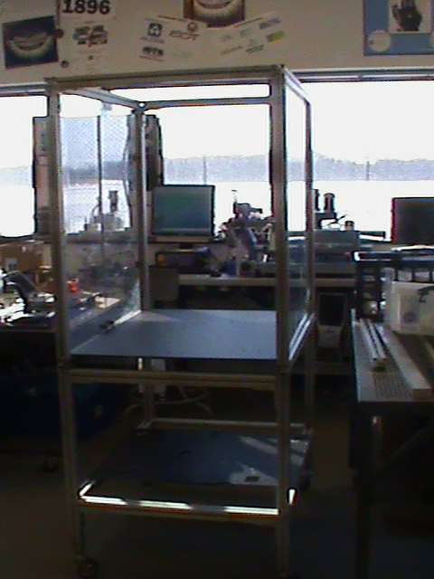
The final SolidWorks models differed greatly from the models created at the start of the project. Modifications were made to the SolidWorks in order to correctly represent adjustments made in the physical cell to optimize process flow. The pictures below depict the SolidWorks model of the frame (left) and the completed cell (right).
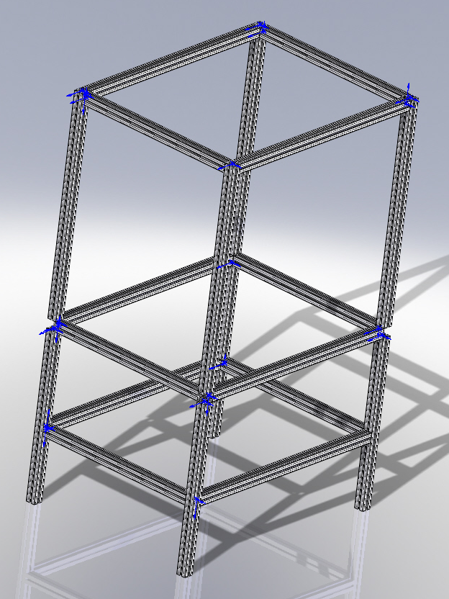
Do 4 - Develop an Action Plan | Study 7 – Analyze the Test Results | Act 8 - Action
Assemble the frame | Parts were missing and frame needed to be resized | Order parts, cut frame stock
Assemble frame with new parts | Resizing components required re-tapping and more parts | Tap components, order parts
Assemble frame with further modifications | Frame was complete | No further action necessary

Developing a Cell Hardware Plan:
Desired components of the cell then needed to be designed. The team confirmed the process flow and created a flow chart (see next page) which then helped to determine what parts needed to be constructed and where they should be placed in the cell. Components were then added to the SolidWorks model of the cell (left). Throughout construction, the team had to revise the layout of the cell to optimize process flow. Therefore, the final SolidWorks model differed from the initial and is show below (right).

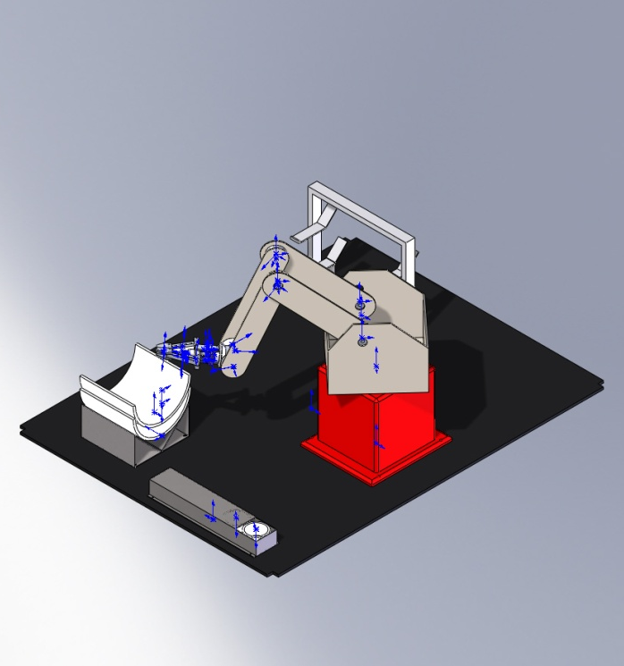

Do 4 - Develop an Action Plan | Study 7 – Analyze the Test Results | Act 8 - Action
Build components to put in cell | Components were not suited to optimal process flow | Change component designs
Change and build newly designed components | Components were conducive to optimal process flow | No further action necessary
Put components in cell | There was no floor in place to secure the components to | Resize board material and implement in cell
Resize and secure board into cell | Board fit in cell and the desired level for components was in place | No further action necessary
Secure components to board level in cell | Holes were drilled in proper places so that components were secured correctly | No further action necessary

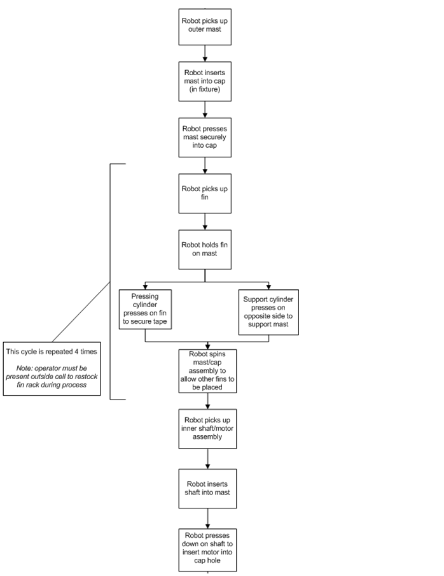
The team used a flow chart to aid in modifying the layout of the cell. This ensured that all processes could be completed most efficiently.
Developing a Software Plan:
The team had an Amatrol Pegasus Robot at hand, but it was not functional at the start of the project. Therefore, the team worked out a plan to fix the robot and have a functioning robotic arm. It also became apparent that other electrical components would be needed, such as a PLC to control the safety stop systems and pneumatic system. Three switches were connected to the PLC: two for safety and one for fin application.

Do 4 - Develop an Action Plan | Study 7 – Analyze the Test Results | Act 8 - Action
Begin programming robot | Robot was not functional | Acquire necessary sensors, fix robot
Begin programming robot | Robot had accuracy and repeatability issues | Tighten chains to address accuracy issue
Program points in robot | Robot was not homing correctly, resulting in varying points upon each start-up | Create system for accurate homing: mark robot
Program points | Points worked correctly | No further action necessary
Write program on computer | Program language was foreign to team members | Ben learned how to write a program for the robot
Write program | Adjustments were made to the process in the cell resulting in a change in the program | Rewrite program
Program was adjusted | Program worked properly | No further action necessary
Set up pneumatic system | One cylinder proved problematic to later processes in the cell | Set up a second cylinder
Modify pneumatic system | Two cylinders allowed for proper application of fins, completion of process | No further action necessary
Implement switches | Safety switches on doors and emergency stop worked properly, cylinder activation switch was functional | No further action necessary

An outline of the program and a snapshot of the ladder diagram for the Programmable Logic Controller are found in Appendix B. Electrical and pneumatic schematics are found in Appendix C.

The table below outlines the difficulties that the team encountered while programming the robot.

Process | Trial # | Pass/Fail | Problem | Solution
Move robot arm to P1 | 1 | P
Move robot arm to P2 | 1 | F | Claw ran into robot | Moved P2 further from robot
Move robot arm to P2 | 2 | P
Move claw to P3 | 1 | P
Close gripper/grasp mast | 1 | P
Move robot arm/mast to cap  (P4) | 1 | F | Mast was not in line with cap | Redefine P4
Move robot arm/mast to cap  (P4) | 2 | P
Push mast into cap  (P5-P10) | 1 | F | Mast ended up crooked | Reprogram points
Push mast into cap  (P5-P10) | 2 | P
Move robot arm to pick up fin (P19) | 1 | F | Knocked mast over | Program claw to move above mast
Move robot arm to P19 | 2 | F | Still did not clear mast | Program additional points to clear mast
Move robot arm to P19 | 3 | F | Claw ran into PVC fixture | Move robot arm to P2 prior to P19
Move robot arm to P19 | 4 | P
Pick up fin | 1 | P
Move fin to mast | 1 | F | Fin hit fixtures | Program multiple points between closing of claw and moving to mast
Move fin to mast | 2 | F | Still hit fixtures | Program more intermediary points
Move fin to mast | 3 | P
Apply fin to mast | 1 | F | Fin was crooked | Adjust application point (P29)
Apply fin to mast | 2 | F | Fin did not trigger sensor required to actuate pneumatic cylinders used to press fins to mast | Adjust P29
Apply fin to mast | 3 | P
Rotate mast | 1 | F | Claw did not grip mast properly | Adjust grip point (P30) to grab more centrally
Rotate mast | 2 | P
Repeat sequence three additional times | 1 | P
Move to rack to grab shaft (P33) | 1 | F | Knocked mast over | Move claw above mast first
Move to P33 | 2 | F | Ran into shaft fixture | Move to P1 first
Move to P33 | 3 | P
Close claw to grab shaft | 1 | F | Was not properly aligned to grasp shaft | Adjust close point (P34)
Close claw to grab shaft | 2 | P
Move shaft to mast (P38) | 1 | F | Shaft hit fixture | Adjust points (P35-P38)
Move shaft to P38 | 2 | P
Insert shaft into mast (P39, P40) | 1 | F | Did not fall into mast | Adjust points
Insert shaft into mast | 2 | F | Shaft sat on lower bushing | Add “knock in” points to ensure placement
Insert shaft into mast | 3 | P
Motor shaft should be in hole in cap | 1 | F | Motor shaft did not get pushed into hole | Have robot push shaft down
Motor shaft should be in hole in cap | 2 | P

This is not an exact depiction of the occurrence of events because doing so would literally create a report of its own. The Amatrol Robot used in this work cell is a 15 year old machine. Many problems arose throughout the construction and operation of the work cell due to the age and past use of the robot.
Between September of 2010 and January of 2011, one of the team members was working solely on fixing the robotic arm: as of September, the robot was completely non-functional. Multiple sensors had to be replaced, and much work was done to create a functioning robot. However, there were still major issues of accuracy and repeatability in the robot. Because of those issues, the team had to reprogram points any time the robot was moved to a new location as movements in the chains and other mechanisms of the robot resulted in major variation of maneuverability. In addition, the sensor controlling the fourth axis of the robot was not completely corrected; it shorted out frequently and did not allow the robot to home the fourth axis correctly. The team was forced to compensate for this issue by homing from exactly the same angle in regards to the fourth axis.
These issues resulted in complications prior to the National Robotics Challenge competition in Ohio by presenting the team with the need to find the “perfect” spot to begin homing, and by making the programming process very difficult to the variability of points when repeated. Once at the competition, the team had to again reprogram many points because the shifting during travel only decreased the accuracy and repeatability of the robot even further. The team was able to have the cell perform a complete program during setup at the competition, yet still had to reprogram points for the actual competition time the next day.
The team was invited back to the competition for further judging the next day as nominees for the Honda Innovation Award. That following day of judging provided yet another situation where much reworking was needed in the cell, and actually resulted in a poor presentation at the second round of judging. During that time, an error occurred in one of the sensors that led to a serious issue when the program was asked to repeat a sequence of points. At that time, the robot actually moved a particular point each time the sequence was repeated which resulted in complete failure of the task. After the competition, the team replaced the sensor, and began reprogramming points, in an attempt to reduce issues related to accuracy and repeatability.

At the MTA, the instructors push for students to take charge of projects for the NRC. That was the case this year resulting in a completely student-designed and student-built Work Cell. The team was able to design and build the components detailed below, with varying levels of guidance from mentors and business partners.

Item | Student Designed? | Student Built? | Outside assistance?
Cylinder mount | Yes | Yes | No
Cylinder plates | Yes | Yes | No
Cap rack | Yes | Yes | No
Fin rack | Yes | Yes | No
Mast rack | Yes | Yes | No
Shaft rack | Yes | Yes | No
Bushings in masts | Yes | No | Yes
Frame | No | Yes | No
Robot repair | No | Yes | Yes

Conclusion

The Wind Turbine Team of four seniors from the Manufacturing Technology Academy designed and constructed a work cell that assembled small vertical wind turbines. The team utilized the Plan Do Study Act problem solving technique to work through engineering problems encountered during this project.
Ultimately, the work cell properly assembled wind turbines and the product was able to give an output voltage showing that the turbine could in fact be used as an energy source. At the National Robotics Challenge the team was nominated for the Honda Innovation Award and was given the Gold Award in the Manufacturing Robotic Work Cell competition.
If extra time was available and the team planned to use the work cell for production, some modifications would be made to increase efficiency of both the work cell and the wind turbine product.

Appendix A

See attached Gantt Chart.

Appendix B

Ladder Diagram for PLC

Appendix C
Electrical Schematic
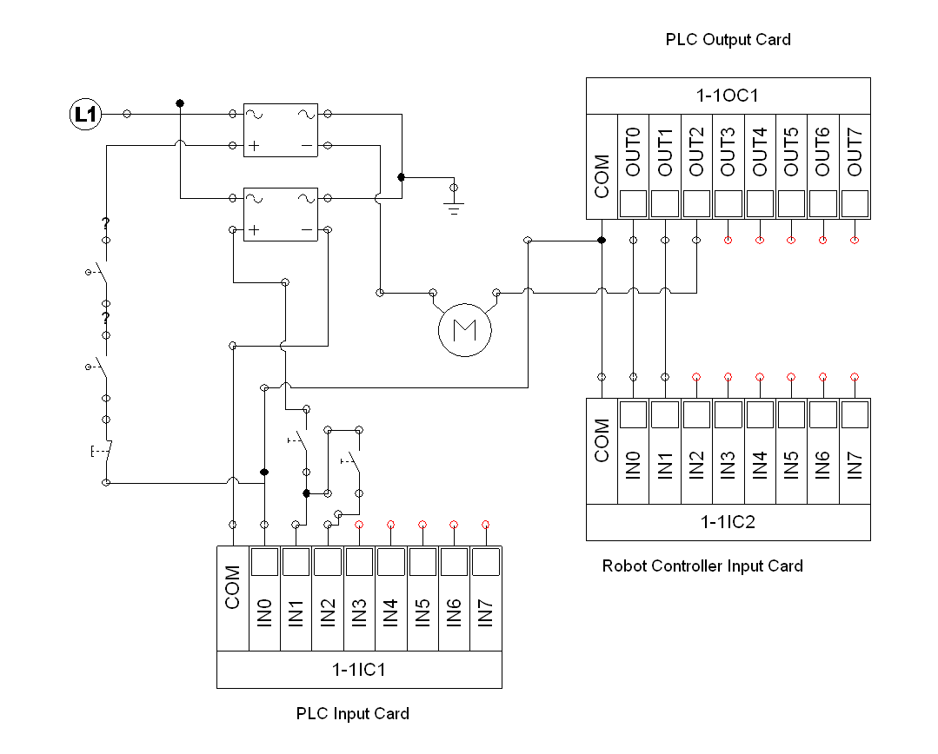

Pneumatic Schematic
