Corrie Noah
May 26, 2011

Internship Summary: Electro-Optics Technology and Graceland Fruit Inc.

My internship consisted of five hours working on my own time for Electro-Optics Technology (EOT) under the direction of Kim Dunneback, Sales Manager at EOT. In addition, I logged nearly 30 hours working at Graceland Fruit Inc. in the Waste Water Treatment Plant under the supervision of the Plant Manager Jessica Wooten.
My duties at both companies required me to work on my own. Therefore, it was vital for me to manage my time wisely and to solidify my integrity. My task for EOT was to revise two product specification sheets. Both documents were handed to me as two page entities and the request was for all information to be only on the front side of one piece of paper. The result of my work was then two new product specification sheets that were only one page in length.
In the Waste Water Treatment Plant (WWTP) at Graceland I was responsible for ensuring that 12 Material Safety Data Sheets (MSDS) notebooks matched the company’s online MSDS database. For all but one of my thirty hours I worked at a computer, in solitude, on this project. The one odd hour was spent chiseling an iron shale precipitate out of a large pipe. This was due to a hectic day at the WWTP and the need for a small job to be done.
Due to working solely outside of the company during my work for EOT, I really didn’t encounter any manufacturing processes within that company. However, I have a bit of background knowledge about the company and know that they produce laser products, fiber isolators, and photodetectors. Within EOT employees use shop equipment, conduct machine maintenance, report to supervisors, and carry out routine chores.
While I did not work directly with any manufacturing processes in the WWTP either, I observed the processes listed above as well as inspection of machine tools and routine adjustments throughout the plant as needed.
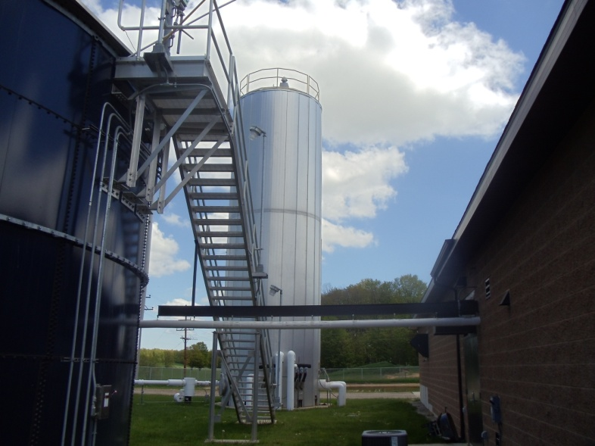
The only technical skills I really utilized throughout my internship work were basic computer skills and interpretation of technical documentation.

